0；【】跑不过【M[Table_Main]
研究报告Research Report
21 Oct 2025
Textron (TXT US Equity)
A Diversified Industrial Giant Leading in the General-Aviation Jet Market : Initiation
 |  | Textron: a diversified industrial giant with over 100 years of history. Founded in 1923, Textron is a global diversified industrial giant focused on aviation, defense, industrial, and finance sectors. Its core business units include Textron Aviation, Bell, Textron Systems, Industrial, and Textron eAviation. From 2015 to 2025, revenues increased from 13.423 billion USD to 14.799 billion USD, with a CAGR of 0.98%. Manufacturing businesses account for 99% of revenues, among which Textron Aviation represents 38.6%, Bell 26.1%, Industrial 25.6%, and Textron Systems 9.1%. Gross margins have remained stable at 16-18%, and net profits grew from 0.697 billion USD to 0.921 billion USD from 2015 to 2025, with a CAGR of 2.8%.  Textron Aviation is a global leader in general aviation, with a leading market share in jets. Textron Aviation is Textron's largest business segment, with 2025 revenues of 5.955 billion USD (accounting for 38.6%), integrating the Cessna and Beechcraft brands and focusing on jets, turboprops, and piston aircraft. The Cessna Citation series jets lead globally with a 20% market share, featuring a product line from entry-level (M2/CJ series, priced at 6-12 million USD) to super-midsize (Longitude, with a range of 6,480 km), emphasizing low costs, high comfort, and reliable after-sales service. Demand is strong, with order backlogs extending to 2028, benefiting from market recovery and new model certifications; but short-term attention is needed on supply chain issues leading to production capacity that requires improvement.  Performance varies across other segments. 1) Bell: 2025 revenues of 4.282 billion USD. Among them, the military aircraft model MV-75 is expected to drive accelerated deliveries due to its mature technology and superior performance; commercial models see strong demand, with robust performance in North America/Asia-Pacific. 2) Industrial: 2025 revenues of 3.213 billion USD; Kautex (automotive parts) benefits from rising PHEV/EV penetration rates; Specialized Vehicles (such as E-Z-GO) show mixed demand, with resilience in golf/community sectors but weakness in commercial areas. 3) Textron Systems: 2025 revenues of 1.247 billion USD; main products include unmanned systems, intelligence surveillance reconnaissance, armored vehicles, training simulators, and special mission solutions, serving the U.S. Department of Defense and other allied clients.  Valuation and recommendations. We project Textron's revenues for 2026-2028 to reach 15.665/16.638/17.520 billion USD, respectively, with net profits of 1.050/1.161/1.288 billion USD. Based on the Discounted Cash Flow (DCF) valuation model, we initiate coverage with a "Hold" rating and a target price of 83.01 USD.  Risk. Fluctuations in raw material prices; supply chain disruptions; intensified market competition; changes in customer demand; policy changes.
  [Table_Info]
  评级调整Rating adjustment
  评级
  现价
  目标价
  市值
  发行股票数目
  1年股价最高最低值
  注：现价xx为yyyy年M月d日收盘价
  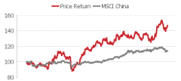
  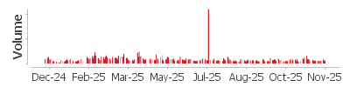
  资料来源： xxx
  [Table_Profit]
  营业收入
  (+/-)
  净利润
  (+/-)
  全面摊薄EPS
  毛利率
  净资产收益率
  市盈率
  资料来源：公司信息, xxx
[Table_Author]
Bin Yang
harryyang@hfisec.com.hk

Contents
1 Textron: A Diversified Industrial Giant with Over Forty Years of History 3
1.1 Company Overview 3
1.2 Ownership Structure & Management 4
1.3 Financial Performance 5
2 Textron Aviation: Broad Product Portfolio with Global Leadership in Business Jets 7
2.1Business Jets: Cessna Maintains a Clear Global Lead 7
2.2 Why Is the Cessna Jet Series the Global Leader? 10
2.3 Cessna Orders Outpace Supply, Production still needs to increase 12
3 Bell Segment: Accelerating Military and Commercial Deliveries 15
3.1 Military aircraft: MV-75 as a key growth driver 15
3.2 Commercial aircraft: Strong demand with improving deliveries 17
4 Industrial Business Segment: Segment business performance is different 20
4.1 Kautex: PHEV+EV Penetration Rate Increase Drives Business Revenue Upward 21
4.2 Specialized Vehicles: Demand fluctuates, with limited Short-term Momentum 24
5 Defense Systems Segment: Short-Term Order-Driven Improvement 25
6. Valuation& Recommendation 27
6.1 Profit Forecast 27
6.2 Valuation Analysis 29
7. Risk 30

1 Textron: A Diversified Industrial Giant with Over 100 Years of History

1.1 Company Overview
Textron Inc. was founded in 1923 and currently operates through six business segments: Bell, Textron Aviation, Textron eAviation, Industrial, Textron Systems, and Finance. Originally established in Boston by Royal Little as the Special Yarns Corporation—a small textile enterprise—the company is now headquartered in Providence, Rhode Island, USA. As a diversified global industrial conglomerate, Textron focuses on aviation, defense, industrial, and financial sectors, with its aviation business holding a leading position in both general and military aviation.

In the 1930s, the company was renamed Atlantic Rayon Corporation and adopted the name Textron Incorporated around 1945 (simplified to Textron Inc. in 1956). It was listed on the New York Stock Exchange in 1947. During the 1950s, under Royal Little's leadership, Textron pioneered the conglomerate model, diversifying away from its textile roots through strategic acquisitions. In 1960, the company acquired Bell Aerospace (including Bell Helicopter) and E-Z-GO, marking its entry into aviation and transportation. Bell Helicopter subsequently became one of its core aerospace assets.

Textron further strengthened its aviation portfolio through subsequent acquisitions, including iconic brands such as Cessna and Beechcraft. In 2014, Textron acquired Beechcraft for approximately $1.4 billion, merging it with Cessna to form Textron Aviation. This integration brought together the Beechcraft, Cessna, and Hawker brands, significantly enhancing its position in the general aviation market.

As of recent years, Textron Aviation has delivered over half of the world’s general aviation aircraft and maintains a broad customer base and service network across more than 170 countries. The company continues to drive innovation, with products such as Bell's V-22 Osprey tiltrotor aircraft serving both military and civilian applications.

As of 2025, Textron is a global enterprise with annual revenues exceeding $13.7 billion, employing approximately 35,000 people, and operating in over 25 countries. It remains a highly competitive and innovative leader in the aviation and defense industries.

Figure: Development History of Textron
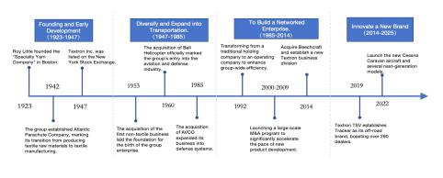
Source: Wind, HFI

1.2 Ownership Structure & Management
Textron is a publicly listed company with a highly institutionalized ownership structure and no single controlling shareholder. Through equity tracing, its ultimate ownership is predominantly held by leading global institutional investors. The Vanguard Group serves as the largest shareholder with approximately 12.77% ownership, followed by BlackRock with about 9.49%. Textron maintains 100% absolute ownership of its key operating divisions, including Textron Aviation, Bell, Industrial, and Textron eAviation, thereby securing full control over globally recognized aviation brands such as Cessna, Beechcraft, and Bell.
Figure: Ownership Structure of Textron（2025/9/30）
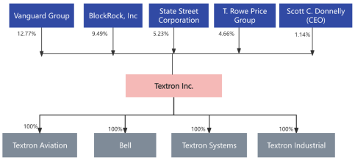
Source: Wind, HFI

Textron's management team is predominantly characterized by internal promotion and long-term service. As of early 2026, Lisa M. Atherton assumed the role of President and Chief Executive Officer on January 4, 2026, and was appointed to the Board of Directors. Prior to this, she served as President and CEO of the Bell segment for an extended period, bringing nearly two decades of internal leadership experience at Textron. Concurrently, Scott C. Donnelly transitioned to the role of Executive Chairman, having previously held the position of President and CEO for 17 years. He continues to provide strategic guidance and board leadership to the company. This model of internal succession and orderly transition further reinforces the stability of the management team and its deep understanding of the company's operations. This approach supports sustained innovation and efficient execution across business units such as Textron Aviation.

Figure: Senior Management Overview of the Group
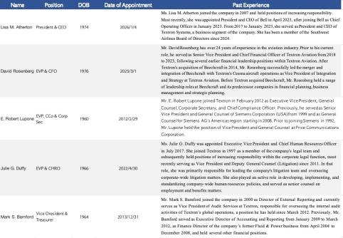
Source: wind, HFI

1.3 Financial Performance
From 2015 to 2025, the company’s revenues showed an overall slight upward trend amid fluctuations. Total revenue increased from USD 13.423 billion in 2015 to USD 14.799 billion in 2025, representing a ten-year CAGR of approximately 0.98%. Specifically, revenue remained relatively stable between 2015 and 2019, peaking at USD 14.198 billion in 2017, with minor fluctuations driven by aviation market demand and defense orders. In 2020, revenue declined sharply by 14.5% to USD 11.651 billion due to the impact of the global pandemic. From 2021 to 2023, supported by a strong recovery in aviation demand and growth in defense operations, revenue achieved consecutive positive growth rates of 6.3%, 3.9%, and 6.3%, respectively. In 2025, revenue increased by 8% year over year, marking a rebound from the prior year and underscoring the company’s long-term stability supported by a diversified business portfolio and resilient end markets.

Figure: Textron Aircraft Revenue and Growth Rate (USD Million)
Source: Wind, HFI
From 2015 to 2024, manufacturing operations—comprising Textron Aviation, Bell, Textron Systems, Industrial, and Textron eAviation—consistently accounted for around 99% of total revenue, while the Finance segment remained under 1% throughout the period.
Within manufacturing, Textron Aviation has remained the largest contributor, with its revenue share staying relatively stable in the 35%–40% range, reaching 40.2% in 2025. The Bell segment’s contribution gradually increased from approximately 20%–25% in earlier years to 28.9% in 2025, largely driven by growth in military programs. Industrial operations fluctuated between 20% and 30%, ending 2025 at 21.7%. Textron Systems typically represented 8%–12% of total revenue, accounting for 8.4% in 2025, whereas Textron eAviation, still in its early-stage development, contributed only 0.18% in 2025.

Chart: Revenue Breakdown by Business Segment at Textron
Source: Wind, HFI

The company’s profitability exhibited some volatility between 2015 and 2024, with gross margins generally ranging from 16% to 18% and net profit margins largely stabilizing between 5% and 6%.

1) Gross Profit Margin：From 2015 to 2024, the company's gross margin consistently remained within the 16%–18% range, except in 2020 when it fell significantly to 13% due to severe disruptions caused by the COVID-19 pandemic. The overall stability in gross margin was primarily supported by the scale advantages and stable pricing power of Textron Aviation and Bell—two core business segments. Sustained delivery volumes in commercial aircraft and helicopters, relatively efficient supply chain operations, and manageable raw material and labor costs further contributed to margin resilience.

- Net Profit Margin: Net profit increased from USD 697 million in 2015 to USD 824 million in 2024, representing a compound annual growth rate (CAGR) of approximately 4%. The net profit margin rose from 5.19% in 2015 to 6.01% in 2024, although sharp declines were observed in 2017 and 2020. The drop in 2017 was primarily attributable to a substantial non-cash one-time income tax expense recorded by Textron under the "deemed repatriation" provision of U.S. tax reform, which significantly reduced reported net income for the year. In 2020, profitability was severely impacted by the global COVID-19 pandemic, which caused a sharp contraction in order demand for core businesses such as general aviation and civil helicopters, widespread supply chain disruptions, and delays in production and deliveries, ultimately weighing heavily on earnings.

3) Stable Expense Ratio
Textron’s operating expense ratio remained steady between 8% and 9% throughout 2015–2024, with a gradual declining trend in recent years, reflecting effective cost management and operational discipline.

Figure: Textron's Gross Margin, Expense Ratio, and Net Profit Margin |  | Figure: Textron's Net Profit and Year-over-Year Growth Rate (USD Million)
Source: Wind, HFI |  | Source: Wind, HFI

Figure: Operating Profit Margin by Business Segment
Source: Wind, HFI

2 Textron Aviation: Broad Product Portfolio with Global Leadership in Business Jets

2.1Business Jets: Cessna Maintains a Clear Global Lead
Textron Aviation primarily operates through two core brands, Cessna and Beechcraft, with Cessna serving as the principal revenue contributor, particularly in the business jet segment. From 2015 to 2025, Textron Aviation’s revenues increased from USD 4.822 billion to USD 5.955 billion, representing a CAGR of approximately 2.1%. The Cessna brand’s flagship products are the Citation series business jets, with key models including CJ3, CJ4, VI/Excel/XLS, Latitude, and Longitude. In 2024, business jets accounted for approximately 41% of Textron Aviation’s total segment revenue, underscoring Cessna’s strong positioning in the global light- and mid-size jet markets.Beyond business jets, the Cessna portfolio also includes single-engine piston aircraft (e.g., 206/T206), single-engine turboprop aircraft (e.g., Cessna Caravan), as well as new-generation twin-engine turboprops such as the Cessna SkyCourier, further enhancing product coverage across multiple general aviation categories.The Beechcraft brand is primarily focused on turboprop aircraft and high-performance piston aircraft. As of 2024, Beechcraft aircraft contributed approximately 24% of Textron Aviation’s segment revenue, serving as an important complement to Cessna’s jet-dominated product mix.

Figure: Revenue breakdown of Textron Aviation segment (USD million) |  | Figure: Cessna business jet revenue and share of aviation segment revenue (USD million)
Source: Wind, HFI |  | Source: Wind, HFI

Figure: Cessna business jet portfolio |  | Figure: Cessna turboprop aircraft portfolio
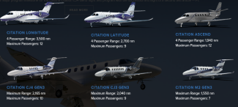 |  | 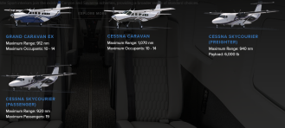
Source: TXT, HFI |  | Source: TXT, HFI

Figure: Cessna piston aircraft portfolio |  | Figure: Beechcraft aircraft portfolio
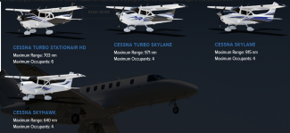 |  | 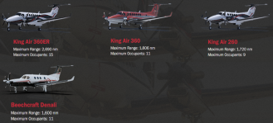
Source: TXT, HFI |  | Source: TXT, HFI

From an overall aircraft model perspective, Textron ranks second globally in terms of aircraft deliveries. According to data from the GAMA, in 2023, Cirrus Aircraft, Cessna, and Diamond Aircraft delivered 708, 618, and 273 aircraft, respectively, with Cessna ranking second worldwide by unit deliveries.From a revenue (sales value) perspective, Textron Aviation accounted for approximately 15.5% of global general aviation aircraft sales, ranking first globally, reflecting the company’s strong product mix and higher average selling prices driven by its leadership in the business jet segment.

Figure: Aircraft manufacturer rankings
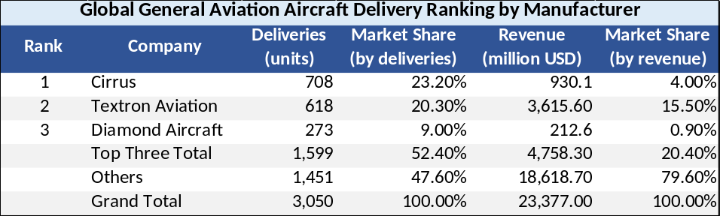
Source: GAMA, Wind, HFI

Breaking down by aircraft type, Textron Aviation holds a clear leading position in the business jet segment.
- Piston-engine aircraft: Based on delivery volumes, the top five global piston-engine aircraft manufacturers accounted for a combined 84.6% market share in 2024. Cirrus Aircraft ranked first with a 31.9% market share (a significant increase from approximately 24.1% in 2020), while Textron Aviation’s Cessna, Beechcraft, and Pipistrel brands together accounted for approximately 19% of the market.

Figure: Global piston aircraft delivery market share(units)
Source: GAMA, HFI

2) Business jets: In 2024, the top five global business jet manufacturers accounted for a combined 86.91% market share, with Cessna ranking first at approximately 20%.

Figure: Global business jet delivery market share(units)
Source: GAMA, HFI

2.2 Why Is the Cessna Jet Series the Global Leader?
The Citation product lineup is characterized by its broadest and most comprehensive tiered coverage. Textron’s business jets span entry-level models such as the M2 and CJ series, mid-size aircraft including the Latitude and Ascend, and super-midsize jets such as the Longitude, effectively covering nearly all mainstream demand from the light to the super-midsize business jet segments.

- Entry-level and light business jets
The segment mainly includes the Citation M2 Gen3, CJ3 Gen3, and CJ4 Gen3 models, positioned for short- to medium-range, high-efficiency business travel, single-pilot operations, and entry-level private or corporate use. The Citation M2 Gen3 has a range of approximately 2,870 km, the Citation CJ3 Gen3 about 3,780 km, and the Citation CJ4 Gen3 around 4,010 km, with unit prices generally ranging from USD 6–12 million. Aircraft in this category emphasize low operating costs, short-field performance, and ease of operation, making them well suited for first-time business jet owners or as supplements for pilot training fleets.

- Mid-size business jets
The Latitude offers a range of approximately 5,000–5,280 km, while the Citation Ascend (entering service soon) provides a range of about 3,590 km in a four-passenger configuration. Both aircraft feature flat-floor, wide cabins, low cabin altitude (6,000 ft at FL450), and a high level of passenger comfort, with unit prices of approximately USD 18–20 million. The Latitude has historically been a best-selling model in the mid-size segment, while the Ascend, leveraging next-generation Garmin avionics and improved fuel efficiency, is positioned to redefine efficiency in the mid-size market, making both aircraft well suited for transcontinental business travel and corporate commuting.

- Super-midsize business jets
The flagship Citation Longitude offers a range of approximately 6,480 km (four-passenger configuration) and a cruise speed of 483 knots, enabling long-range missions including transatlantic flights. With a unit price of approximately USD 28–30 million, the Longitude stands out in the super-midsize segment due to its low operating costs, large flat-floor cabin, and advanced avionics, making it one of the most competitive offerings in the category and widely used for high-end private and long-range corporate travel.

Figure: Performance comparison of Cessna’s core models
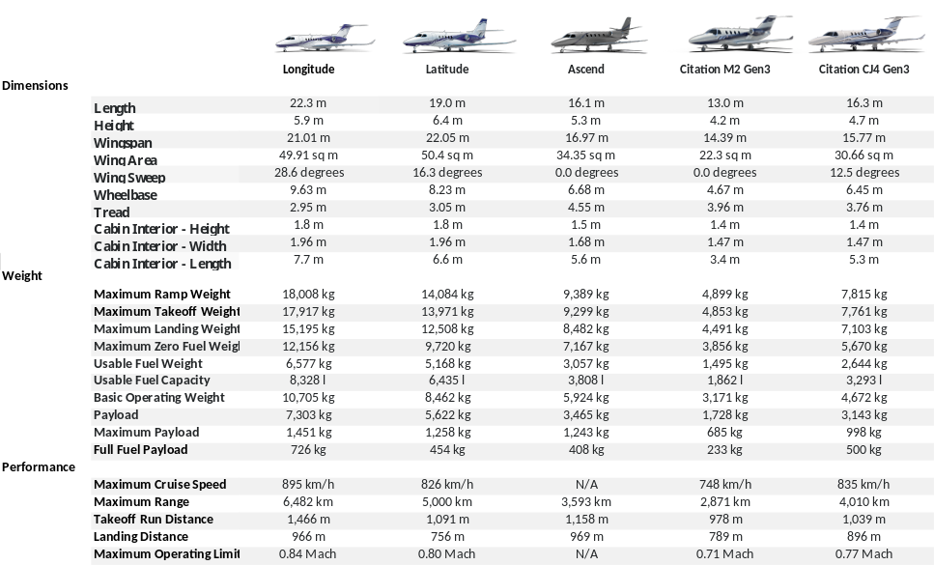
Source: Cessna, HFI

Cessna business jets emphasize a balanced combination of light-jet economics and mid-size comfort, enabling the brand to maintain long-term leadership in deliveries and market share across the light and mid-size business jet segments. In the mid-size and super-midsize categories, the Latitude and Longitude offer low cabin altitude (6,000 ft at FL450, reducing passenger fatigue), flat-floor wide cabins, and strong short-field performance (short takeoff distances allowing access to more airports), while maintaining ownership thresholds and maintenance simplicity closer to those of light jets. By comparison, competitors such as the Phenom 300E offer higher cruise speeds but feature narrower cabins and higher cabin altitudes, while the Gulfstream G280 provides a more luxurious experience at a significantly higher cost. In the light jet segment, according to Textron Aviation’s 2024 disclosures, the Citation CJ4 Gen3’s operating costs are nearly 10% lower than those of its closest competitor.

Figure: Performance comparison between Citation mid-size and super-midsize jets and competitors
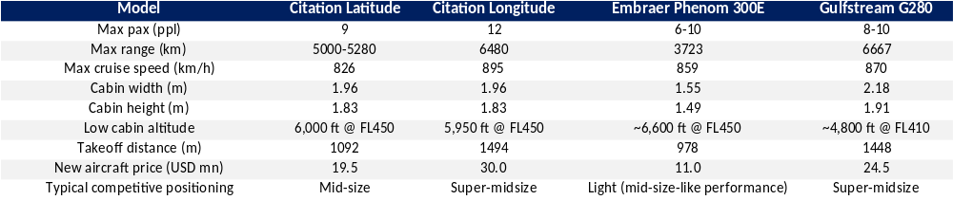
Source: Cessna, Gulfstream, EMBRAER, AviaCost, HFI

Cessna aircraft are known for their reliability, durability, and the world’s largest aftermarket support ecosystem, which together constitute a key source of competitive advantage. Textron Aviation operates a global service network spanning over 170 countries, offering rapid parts availability, short response times, and industry-leading MRO (maintenance, repair, and overhaul) capabilities. By comparison, fleets operated by Pilatus and Embraer are smaller in scale, with less dense aftermarket coverage and slower response times in Europe and the Asia-Pacific region, resulting in longer parts lead times and higher operating costs. In addition, the Citation family is built on proven, time-tested designs—with the first Citation delivered in 1972—combined with continuous Gen-series upgrades (including Garmin G3000/G5000 avionics, Autoland, and lithium battery systems), delivering exceptionally high reliability. As a result, Citation aircraft demonstrate stable performance under high-intensity operating conditions—such as charter operations, special missions, and government use—with low failure rates and high dispatch availability.

Figure: Global service locations of Cessna
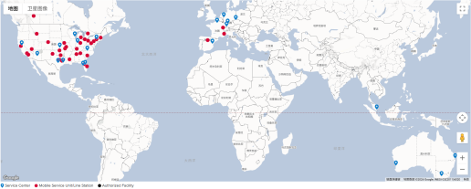
Source: Cessna, HFI

2.3 Cessna Orders Outpace Supply, Production still needs to increase
From an industry perspective, the global private aircraft market is expected to maintain a sustained upward trend in both delivery volumes and value. Private aircraft are increasingly favored due to their high flexibility, privacy protection, safety, time efficiency, and year-round availability. Global deliveries increased from 1,894 aircraft in 2019 to 2,215 aircraft in 2023, representing a four-year CAGR of 4%, while delivery value rose from USD 2.7 billion to USD 3.7 billion over the same period, implying a four-year CAGR of 8.5%. The average selling price increased from USD 1.43 million in 2019 to USD 1.67 million in 2023. Looking ahead, global deliveries are projected to reach 3,185 aircraft during 2025–2028, with delivery value expected to increase to approximately USD 6.4 billion.

Figure: Worldwide Private Aircraft Deliveries (units) |  | Figure: Global Private Aircraft Delivery Value(USD)
Source: GAMA, HFI |  | Source: GAMA, HFI
From a company perspective, demand for Cessna business jets remains robust, accompanied by sustained upward pricing trends. The average backlog coverage for Cessna aircraft is approximately two years. In value terms, order backlog increased by more than 90% from USD 4.1 billion in 2021 to USD 7.8 billion in 2024, representing over a fourfold increase compared with pre-pandemic levels. In addition, certain models are fully sold out through 2028. From a pricing standpoint, price increases for Cessna’s core models have consistently outpaced inflation, with the average aircraft price posting a CAGR of 3.56% over 2014–2024, compared with an average annual increase of 2.98% in U.S. core CPI and 2.85% in headline U.S. CPI.

Figure: Comparison of average Cessna business jet prices and U.S. inflation
Source: Cessna Annual Report, Wind, HFI

In addition, Cessna continues to secure certifications for new and upgraded models, which is expected to further stimulate demand. In 2025, Cessna aircraft obtained several key certifications, including the type certification of the Citation Ascend (a next-generation mid-size business jet), the type certification of the CJ3 Gen2 (an upgraded light jet), and the Garmin Autothrottle certification for the M2 Gen2.The Citation Ascend, featuring next-generation Garmin avionics, improved fuel efficiency, and a flat-floor cabin design, is positioned to redefine efficiency in the mid-size jet segment and fill the gap between the Latitude and Longitude. Meanwhile, the CJ3 Gen2 and M2 Gen2, through avionics modernization and autothrottle upgrades, significantly reduce pilot workload while enhancing safety and operational convenience.Through new model certifications and upgrades to existing platforms, Cessna is expected to continuously strengthen product competitiveness and further stimulate demand in the business jet market.

Figure: Advantages of the new models
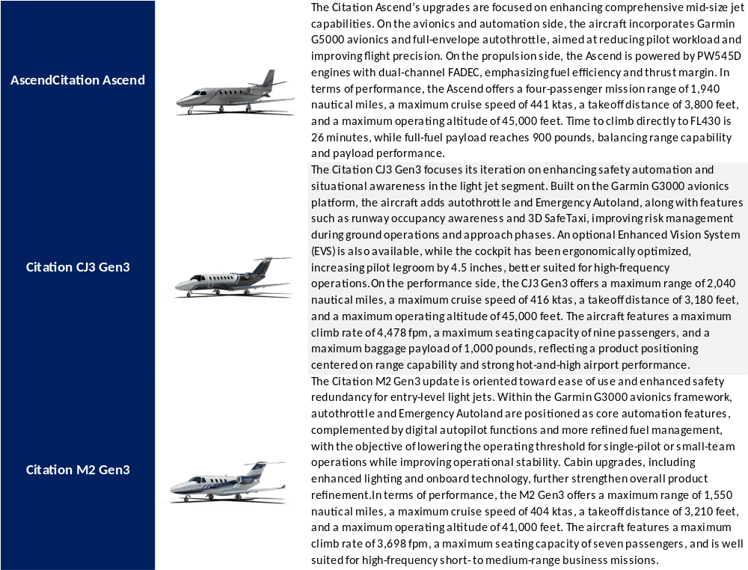
Source: Cessna，HFI

However, production remains below 2019 levels due to ongoing supply chain constraints. In 2019, Cessna delivered 206 business jets, representing a 9.6% year-on-year increase, after which deliveries declined to 151 aircraft in 2024. Despite sustained strong demand, business jet deliveries have yet to recover to 2019 levels, primarily due to supply chain disruptions. On the one hand, business jet production is highly dependent on key systems such as avionics and engines, with engine supply delays in particular proving pronounced, resulting in a significant number of completed airframes awaiting engines prior to delivery. On the other hand, misalignment between component deliveries and final assembly schedules has extended delivery lead times. In addition, a labor strike at Textron Aviation’s production facilities in 4Q24 led to a slower recovery in production efficiency, collectively constraining near-term output growth.
Figure: Textron aircraft deliveries, 2019–2024 (units)
Source: GAMA，HFI

3 Bell Segment: Accelerating Military and Commercial Deliveries

3.1 Military aircraft: MV-75 as a key growth driver
Within the Bell segment’s military portfolio, future growth is expected to be increasingly driven by the MV-75, the aircraft selected as the winning platform for the U.S. Army’s FLRAA program. Prior to 2022, Bell’s military business was primarily centered on the V-22 Osprey and the H-1 helicopter families. Following the formal award of the FLRAA contract to the MV-75 in late 2022, the program has begun to generate initial revenue contributions in line with project milestones. Looking ahead, workload is set to increase materially in 2025, which is expected to drive a significant step-up in military segment revenue on a quarterly basis.

Figure: Textron Bell military revenue and share (USD million) |  | Figure: V-22 and H-1 revenue and year-on-year growth (USD million)
Source: Wind, HFI |  | Source: Wind, HFI

Figure: Textron Bell military aircraft product portfolio
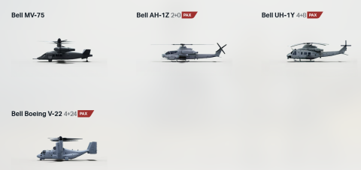
Source: TXT, HFI

- Why did the MV-75 win the FLRAA contract?
1）High technical maturity and the lowest execution risk
Bell’s V-280 is a second-generation tiltrotor, optimized based on the extensive operational experience accumulated from the Bell–Boeing V-22 Osprey, which has been fielded in hundreds of aircraft with millions of flight hours. Key improvements include a simplified clutch system, a straight-wing configuration, lower disk loading, and reduced cost per flight hour. The V-280 program began in 2013 under the JMR-TD (Joint Multi-Role Technology Demonstrator) initiative and has since completed over 200 flight hours of rigorous testing, including high-speed cruise exceeding 300 knots, low-speed agility evaluations, and long-range mission validation, significantly reducing technical risk.
By comparison, the Sikorsky–Boeing SB-1 Defiant X, Bell’s competing bid, adopted a clean-sheet compound helicopter design that was more technically aggressive and carried higher execution risk, having encountered testing delays and technical issues, resulting in a lower level of maturity than the V-280.
Figure: Comparison of maturity and execution risk between the MV-75 and SB-1 Defiant X
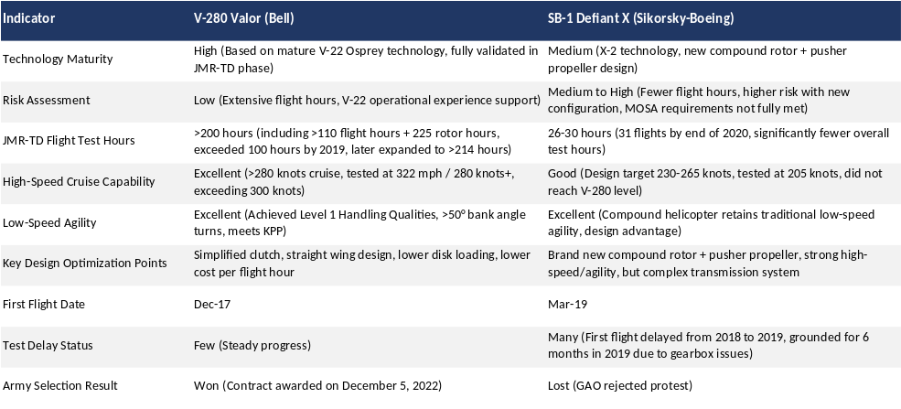
Source: GAO, The War Zone, Wikipedia, HFI

2）Comprehensive performance fully meeting operational requirements
The core FLRAA requirements include a cruise speed of approximately 280 knots (~520 km/h), a minimum range of 1,700 nautical miles without aerial refueling, a troop capacity of around 12 personnel, and hot-and-high operational capability. During the demonstrator phase, the V-280 demonstrated cruise speeds exceeding 300 knots, ranges well above program requirements, and strong agility, fully aligning with the program objective of “twice as far, twice as fast.” In addition, the U.S. Army has placed particular emphasis on high-intensity conflict scenarios in the Pacific theater, where long-range, rapid force projection is critical. The V-280’s tiltrotor configuration—combining vertical takeoff and landing with fixed-wing high-speed cruise—offers a distinct operational advantage in meeting these requirements.

Figure: Performance comparison between the MV-75 and SB-1 Defiant X
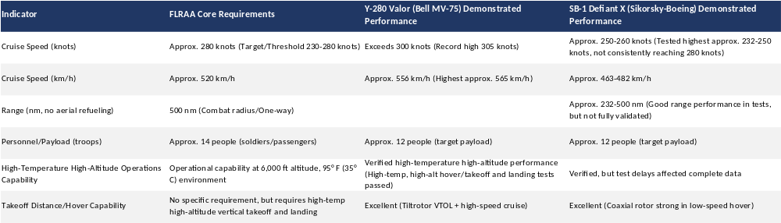
Source: Breaking Defense, The War Zone, Wikipedia, CRS, HFI

- Assessing MV-75's Future Growth Drivers for Bell's Military Sector

1）From a revenue perspective
The U.S. Army is actively accelerating the FLRAA program timeline, pulling forward all key milestones, which is expected to drive rapid growth in revenue. Under the original schedule, prototype first flight (six aircraft) was planned for 2026, LRIP (eight aircraft) for 2028, and initial operational capability around 2030. The updated timeline reflects a comprehensive acceleration effort, with the Army now targeting delivery and testing in 2027 and initial operational capability in 2028, representing a 3–5 year advancement versus the original plan. From a revenue perspective, the program is currently in the development, testing, and LRIP phases, during which revenue is recognized under a cost-plus contract structure. As the program transitions into the full-rate production and delivery phase, revenue will increasingly be recognized on a per-aircraft delivery basis, implying a material step-up in revenue contribution over time.

2）From a profitability perspective
In the near term, as the program remains in the early development, testing, and LRIP phases, margins may have a negative impact on the overall profitability of the Bell segment. Over the longer term, as the program transitions into aircraft deliveries and full-rate production, the Bell business is expected to achieve strong profit growth.

Figure: Bell segment operating margin
Source: Wind, HFI

3.2 Commercial aircraft: Strong demand with improving deliveries
Textron’s commercial helicopter portfolio is primarily composed of the Bell 505, Bell 407, Bell 429, Bell 412, and Bell 525, with Bell 505, Bell 407, and Bell 429 accounting for the largest shares. Based on total deliveries over the past three years, the Bell 505 represents the largest proportion, followed by the Bell 407 and Bell 429, with the remainder mainly comprising the Bell 412 and other models. From a revenue perspective over the same period, the Bell 429 contributes the most, followed by the Bell 407, Bell 505, and Bell 412. The Bell 505 Jet Ranger X is positioned as a light single-engine, five-seat helicopter, with pricing in the range of USD 2.0–2.5 million. The Bell 407 is positioned as a light-to-medium single-engine helicopter with six to seven seats, priced at approximately USD 3.0–4.7 million. The Bell 429 is a medium twin-engine, eight-seat helicopter, with pricing of around USD 7.3–7.5 million.

Figure: Deliveries of Bell’s major commercial aircraft (units) |  | Figure: Revenue share of Bell’s major commercial aircraft within total commercial aircraft revenue
Source: Textron Annual Report, HFI |  | Source: Textron Annual Report, HFI

Figure: Performance comparison of Bell’s core commercial helicopter models
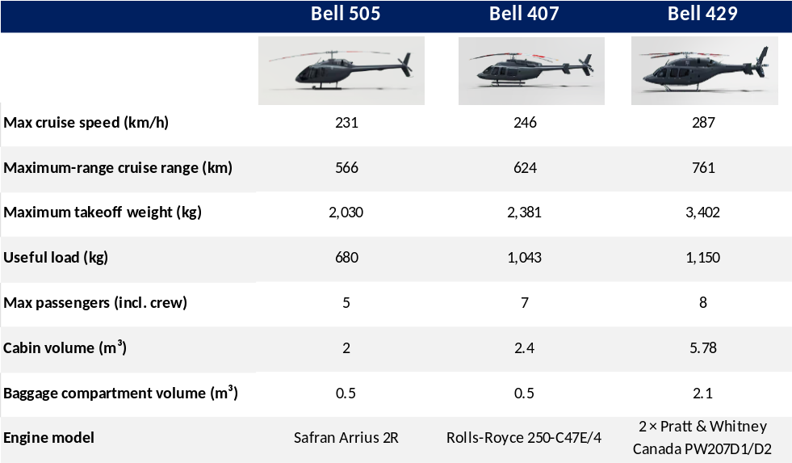
Source: Textron, HFI

The global commercial helicopter market is approaching USD 10 billion in scale and is highly concentrated. As of 2025, the market size reached USD 7.1 billion, and is expected to grow at a CAGR of 4.3% during 2025–2033, reaching USD 9.96 billion by 2033.From a market structure perspective, industry concentration remains high, with the top three players—Airbus Helicopters, Bell Textron, and Leonardo S.p.A.—accounting for over 85% of global market share over the past decade. As of 2024, Airbus Helicopters held 57% market share, followed by Leonardo at 19% and Bell Textron at 18%.

Figure: Global commercial helicopter market size and projected growth (USD billion) |  | Figure: Revenue share of Bell’s major commercial aircraft within total commercial aircraft revenue
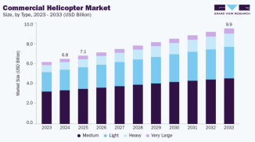
Source: Grand View Research, HFI |  | Source: GAMA, HFI

From a regional perspective, Bell is more competitive in North America and the Asia-Pacific region, while its presence in Europe remains relatively weak. According to Textron’s annual reports, Bell’s revenue in the U.S. market increased by 17% from 2022 to 2024, reaching USD 2.6 billion, while revenue in Europe declined by approximately 39% over the same period. In other markets (including Asia-Pacific), Bell’s revenue has strengthened in recent years, rising to USD 0.85 billion. These regional performance differences are fundamentally driven by a combination of installed base, demand structure, and institutional environments. In the U.S. market, demand is primarily driven by general aviation, public safety, and training, with no domestic protection barriers, allowing Bell to maintain long-term advantages through its mature product portfolio and comprehensive ecosystem. In contrast, the European market is centered on emergency medical services and government procurement, where local manufacturers benefit from clear advantages in procurement processes, certification, and maintenance systems, resulting in Bell’s persistently lower market share. Meanwhile, the Asia-Pacific market lacks a dominant local OEM and features a demand structure more similar to North America, enabling Bell’s product mix and operating model to remain highly competitive, thereby shaping a regional landscape of continued strength in North America, improving momentum in Asia-Pacific, and relative weakness in Europe.

Figure: Bell revenue by region, 2022–2024 (USD million)
Source: Textron Annual Report，HFI

Despite a sequential decline in Bell’s commercial deliveries in 3Q25, delivery momentum is expected to improve going forward, supported by solid order demand. Bell’s commercial helicopter deliveries in 2025 have remained broadly stable on a quarterly basis, with 29, 32, and 30 aircraft delivered in 1Q25–3Q25, respectively, totaling 91 units year-to-date. In 3Q25, commercial deliveries declined year-on-year to 30 units (vs. 44 units in 3Q24). The company disclosed that the decline in commercial revenue was primarily delivery-driven, compounded by resource allocation and delivery schedule disruptions related to the accelerated MV-75 military program, which mainly reflects quarterly timing mismatches in delivery recognition rather than a structural weakening in demand. Looking ahead, supported by resilient demand across the commercial product portfolio and normalization of delivery schedules, deferred deliveries are expected to be recaptured in subsequent quarters. At the same time, visible order conversion driven by downstream replacement demand, particularly in EMS applications, provides additional support—for example, GMR’s order for seven Bell 429 helicopters with options for eight more, with deliveries expected to begin in 2026. Combined with Bell’s installed base of approximately 13,000 helicopters, which underpins a stable services revenue base, and the medium- to long-term incremental contribution from the certification of the Bell 525, we expect full-year 2025 and 2026 deliveries and earnings growth to continue to be driven primarily by demand strength and delivery recovery.

Figure: Quarterly deliveries of Bell commercial helicopters in 2024 and 2025 (units)
Source: GAMA

4 Industrial Business Segment: Segment business performance is different
Textron's industrial business segment mainly focuses on two major product lines: automotive components and specialty vehicles, and is the core non-aviation/defense component in the company's diversified businesses. The segment's revenue proportion is approximately 25-26%, mainly operated through Kautex and Textron Specialized Vehicles (including the E-Z-GO brand), of which Kautex accounts for approximately 50-60% of the segment's revenue.
From 2015 to 2024, revenues of the Industrial segment were volatile. Revenue amounted to USD 3.544 billion in 2015 and peaked at USD 4.291 billion in 2018, before declining to USD 3.0 billion in 2020 due to the impact of the COVID-19 pandemic. Thereafter, revenues recovered steadily to USD 3.515 billion in 2024, followed by another decline to USD 3.213 billion in 2025.

Figure: Industrial segment revenue and year-over-year growth rate from 2015 to 2024 (unit: million USD)
Source: Wind, HFI

Figure: Kautex |  | Figure: Textron Specialized Vehicles—E-Z-GO brand
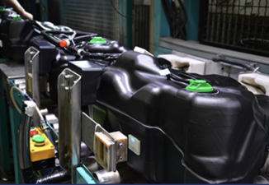 |  | 
Source: TXT Official Website, HFI |  | Source: TXT Official Website, HFI

4.1 Kautex: PHEV+EV Penetration Rate Increase Drives Business Revenue Upward
Kautex is a core subsidiary of Textron's industrial business segment, a globally leading Tier 1 automotive components supplier (one of the top 100 global automotive suppliers), focusing on the design, development, and manufacturing of blow-molded plastic fuel systems and related functional components. Kautex was founded in 1935, acquired by Textron in 1996, currently headquartered in Bonn, Germany, with approximately 30 factories in 13 countries, about 7,000 employees, and as of 2025, this business segment's revenue reached 1.912 billion USD.

Figure: Kautex Development History
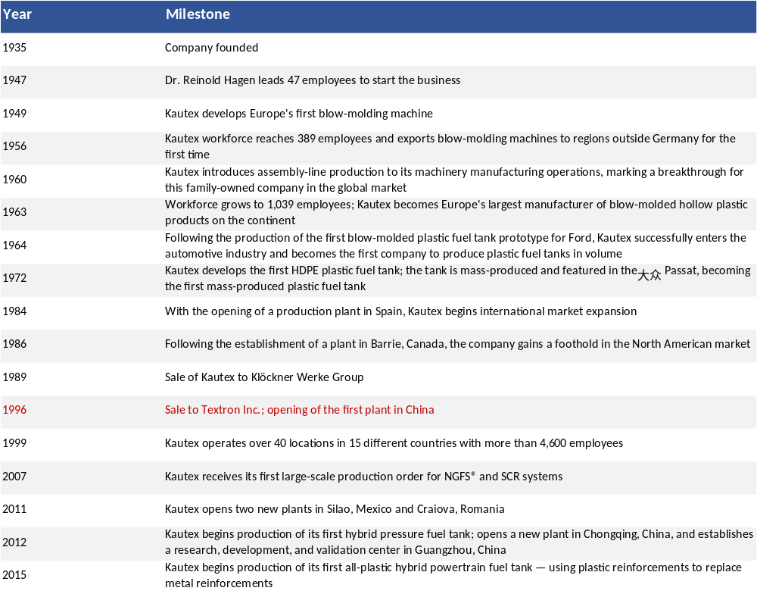
Source: Kautex Official Website, HFI

Kautex's core business is the use of blow molding technology to produce lightweight, corrosion-resistant, high-performance plastic components, with products mainly divided into three major categories: traditional and hybrid fuel systems, electric vehicle and new energy-related components, other functional components and industrial packaging. Among them, traditional and hybrid fuel system products include multi-layer co-extruded blow-molded fuel tanks, high-pressure fuel tanks, selective catalytic reduction systems, etc.; electric vehicle and new energy-related components include battery casings/lower protection plates, high-pressure hydrogen storage tanks; other functional components and industrial packaging include clear vision systems, headlight and windshield cleaning systems, industrial plastic packaging, etc.

Figure: Core business of Kautex
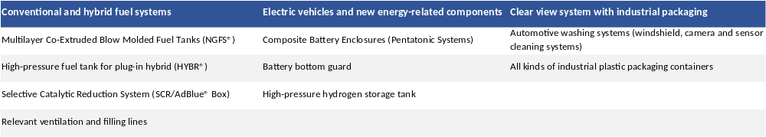
Source: Kautex Official Website, HFI

- Kautex future highlights

1）Fuel system business: Expected to show steady and high-value growth
With the basic support from internal combustion engine (ICE) vehicle production, global light vehicle sales in 2025 are expected to exceed 91 million units, with ICE still accounting for more than 70%, providing support for Kautex's traditional fuel business; at the same time, hybrid vehicle penetration continues to increase, with PHEV sales growth of 20-30% in 2025, and penetration rate moving from ~6% in 2024 to higher levels, driving strong demand for high-requirement fuel systems (such as Hybr® technology), which is expected to further boost the high-pressure fuel tank business upward growth.

Figure: Global hybrid vehicle (PHEV) sales changes from 2014 to 2024 (unit: million units)
Source: IEA, HFI

2）Electric vehicle and new energy components business: Industry growth drives demand upward
The continuous acceleration of global electric vehicle (EV) penetration rate is expected to drive rapid growth in the electric vehicle and new energy business. In 2024, global electric vehicle sales increased by 25%, reaching 17.8 million units. The *Electric Vehicle Sales Report* forecasts that EV sales will hit 23.7 million units in 2025, with a market share of 25.5%. By 2040, global EV sales are expected to grow to nearly 90 million units, accounting for 27.5% of total sales in 2026, 43.2% in 2030, and exceeding 83% by 2040. The rapid rise in global EV penetration is driving significant demand for battery housings and underbody battery shields. Kautex, leveraging its expertise in blow molding technology, offers products like the Pentatonic battery housing, which address the critical needs of EVs for lightweight design, safety protection, and functional integration, positioning the company for strong growth.

Figure: Global electric vehicle share of the light vehicle market and projected trends for 2025–2040
Source: EV Volumes, HFI

4.2 Specialized Vehicles: Demand fluctuates, with limited Short-term Momentum
Textron Specialized Vehicles focuses on the design, manufacturing, and sales of specialized vehicles and professional mobility solutions. Its portfolio includes brands such as E-Z-GO, Cushman, Jacobsen, Arctic Cat, and Textron GSE, covering a diverse range of products from golf carts, commercial utility vehicles, and turf equipment to ground support vehicles for aviation and off-road powersports products. This forms a varied "family of specialized vehicles." From a revenue perspective, this business’s revenues increased from USD 1.021 billion in 2015 to USD 1.525 billion in 2025, representing a CAGR of 4.1%.

Figure: Textron Specialized Vehicles brand product matrix
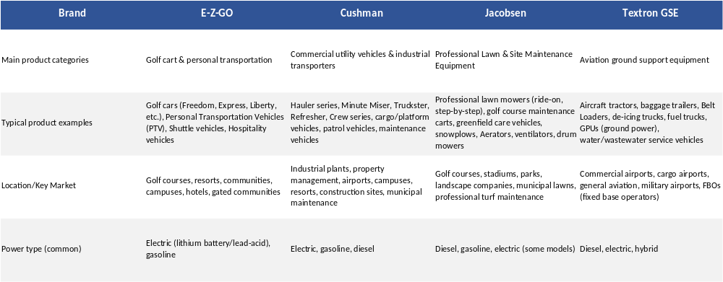
Source: TXT Official Website, HFI

In 2025, demand presents mixed characteristics, lacking consistent upward momentum overall, and is unlikely to become a major driver for profit margin expansion in the industrial sector in the short term. On one hand, the golf course and community personal transportation segments remain relatively resilient. According to the National Golf Foundation (NGF) 2025 report, the number of golf participants in the U.S. has stabilized at over 25 million, continuing the post-pandemic growth trend and reaching 72% in 2025—surpassing the historical peak of 2000. In community settings, the retirement community segment is projected to grow by $47.4 billion from 2024 to 2029, with a CAGR of 4.9%. By Q3 2025, occupancy rates reached 88.7% (independent living at 90.2% and assisted living at 87.2%), up 0.7 percentage points from Q2, collectively driving revenue growth for golf course and community personal transportation vehicles. On the other hand, commercial/industrial utility vehicles (such as the Cushman brand) are performing weakly due to macroeconomic cycles, high interest rates, and cautious spending by consumers and businesses. The divestiture of the Powersports business in 2025 further reduced the overall revenue of the industrial sector (Q3 revenue dropped by $79 million, with $88 million attributed to the divestiture impact). E-Z-GO, as the remaining core segment, has yet to show signs of a strong rebound. Overall, demand for E-Z-GO is clearly diverging, with both positive and negative factors, and short-term growth momentum remains limited. A clearer recovery will likely depend on improvements in the macro environment, such as a rebound in leisure consumption.

Figure: U.S. Retirement Community Market Size (Unit: Billions of USD)
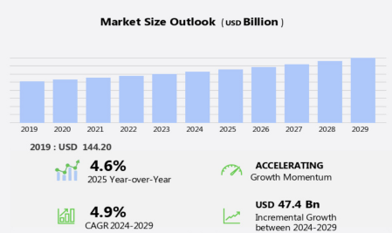
Source: technavio, HFI

5 Defense Systems Segment: Short-Term Order-Driven Improvement
Textron Systems is the business unit of Textron Inc. focused on defense and security systems, primarily consisting of unmanned systems, intelligence, surveillance and reconnaissance (ISR), armored vehicles, training and simulation, and special mission solutions. This segment serves the U.S. Department of Defense (DoD) and allied government customers, with products covering land-based, sea-based, and air-based applications, positioning it as a mid-to-high-end defense technology and systems integration provider. Over the past decade, revenues from this business declined to some extent, decreasing from USD 1.52 billion in 2015 to USD 1.247 billion in 2025. However, total revenues have remained broadly stable over the past four years, with a slight rebound in 2025.

Figure: Textron Systems Revenue and YoY Growth  (in millions of USD) |  | Figure: Textron Systems Product Matrix (Partial)
 |  | 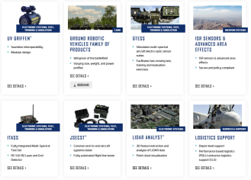
Source: Textron Inc. Annual Report, HFI |  | Source: Textron Inc. Official Website, HFI

Figure: Textron Systems Major Business Segments and Corresponding Service Domains
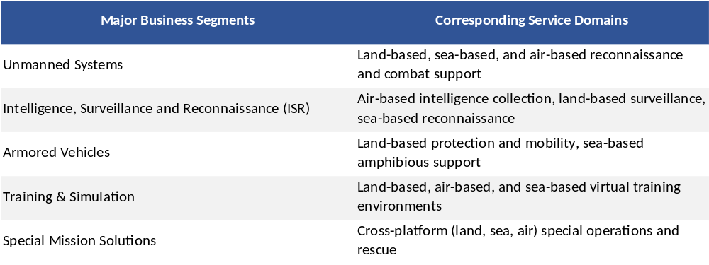
Source: Textron Inc. Official Website, HFI

The global defense electronics and specialized systems market includes sub-sectors such as unmanned ground/aerial systems, armored and protected vehicles, training simulators, intelligence analysis systems, etc. The market size is expected to maintain steady upward growth in the future.In 2024, global defense spending achieved actual growth of 7.4%, with the defense-to-GDP ratio rising to 1.9%. Driven by the Russia-Ukraine conflict, Middle East security crises, and military modernization in Asian countries, budgets are increasingly tilted toward high-tech equipment. Unmanned systems (UAS/UGV), armored and protected vehicles, training simulators (VR/AR), and C4ISR intelligence analysis platforms have become the main growth drivers. Technological pathways are concentrated on modular open systems approach (MOSA), edge AI, gallium nitride (GaN) devices, and anti-jamming communications.
Looking to 2025-2026, the U.S. FY2026 defense budget request is approximately $961.6 billion, Europe is accelerating the implementation of NATO’s “2%+” target, and Indo-Pacific allies are increasing investments in unmanned platforms and electronic warfare, collectively driving market expansion. The global defense electronics systems market is expected to exceed $19 billion in 2025, approach $20 billion in 2026, and surpass $24 billion by 2030, with a compound annual growth rate of approximately 5% during the period and cumulative growth exceeding 70%. In terms of regional structure, North America will continue to hold a dominant share of 38-40%, the Asia-Pacific region will grow the fastest (CAGR 6-7%), while Europe focuses on supply chain autonomy and capabilities in electronic warfare/cybersecurity.

Figure: Global Defense Electronics Systems Market Size (in billions of USD)
2026-2030 Forecast Defense Electronics Systems Market Revenue
2020-2025 Defense Electronics Systems Market Revenue
Source: Bloomberg, HFI
Textron Systems is poised to achieve elevated near-term growth, supported by a significant influx of large-scale orders. In the third quarter of 2025, the segment secured orders exceeding $1 billion, primarily encompassing the ATAC program (aerial targets and training), Sentinel-related missile defense efforts, and multiple armored vehicle contracts. These awards reflect strong alignment between Textron Systems’ core product lines—unmanned systems, training & simulation, and armored vehicles—and the U.S. Department of Defense’s key investment priorities.

6. Valuation& Recommendation

6.1 Profit Forecast
- Total Revenue

- Textron Aviation: Projected total revenues for 2026-2028 are 64.14/68.54/72.96 billion USD, with year-over-year growth rates of 7.70%/6.87%/6.45%, respectively. Among them, aircraft OEM revenues for 2026-2028 are 43.68/47.37/51.09 billion USD, with growth rates of 10.60%/8.45%/7.86%, respectively, mainly driven by delivery volume growth; projected aftermarket service revenues for 2026-2028 are 2%/3.5%/3.3%, respectively.

- Bell Segment: Projected total revenues for 2026-2028 are 46.30/50.43/54.05 billion USD, with corresponding year-over-year growth rates of 8.14%/8.90%/7.18%. Among them, military aircraft revenues for 2026-2028 are mainly driven by the accelerated delivery process of the MV-75; commercial aircraft revenues for 2026-2028 are expected to achieve overall growth rates superior to the industry average, primarily driven by new orders.

- Industrial Segment: Expected to remain stable for 2026-2028, with revenues of 32.40/33.05/33.38 billion USD and year-over-year growth rates of 0.83%/2%/1.00%, respectively.

- Textron System: Overall growth rate higher than the industry average, with projected revenues for 2026-2028 of 13/13.52/13.93 billion USD and growth rates of 4.25%/3.02%/3.0%.

- Other Segments: eAviation and Finance are both expected to maintain steady upward trends.

Based on the above, the company's total revenues for 2026-2028 are projected to be 156.65/166.38/175.20 billion USD, with year-over-year growth rates of 5.85%/6.21%/5.30%.

Figure：2025-2027 Revenue Breakdown by Business Segments (in Million USD)
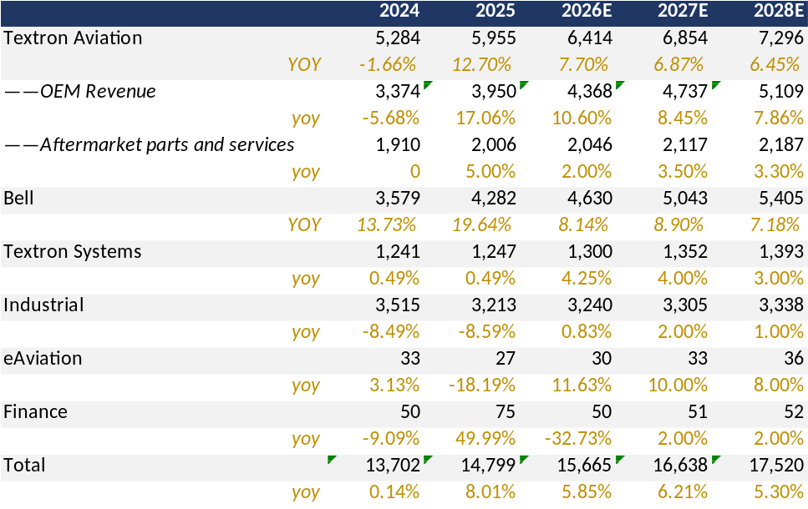
资料来源: Wind, HFI

- Gross Profit Margin

1)Segments that boost the company's overall gross margin: Considering the aviation business segment, where continuous upgrades of aircraft models lead to increased value and gross margins, it is expected to have a positive pulling effect on the company's overall gross margin.
2)Segments that affect the company's overall gross margin: In the Bell segment, because the MV-75 is still in the early delivery process and revenue is accounted for on a cost-plus basis, it is expected that this business will have a certain negative impact on gross margins in the short term.
3)Other segments: Textron System, Industrial segment, and others all maintain relatively stable gross margin levels.

Based on the above, and referring to the revenue proportions of each business, it is expected that gross margins will see a slight upward trend from 2026-2028, with gross margins of 19.5%/19.7%/20%, respectively.

- Period Expense Ratio

SG&A expenses expected to grow steadily, at 9.5%/9.8%/10% for 2026-2028.

In summary, the company's net profits for 2026-2028 are projected to be 10.50/11.61/12.88 billion USD, with yoy growth rates of 14.03%/10.52%/11.01%, respectively.

6.2 Valuation Analysis
Based on the Discounted Cash Flow (DCF) valuation model, we have calculated the company's future operating cash flows, and comprehensively considered the industry growth prospects, the company's competitive position, and profitability, assigning a target price of 83.01 USD to the company. This is our first coverage of Textron, with a "Hold" investment rating.

Figure：DCF Model
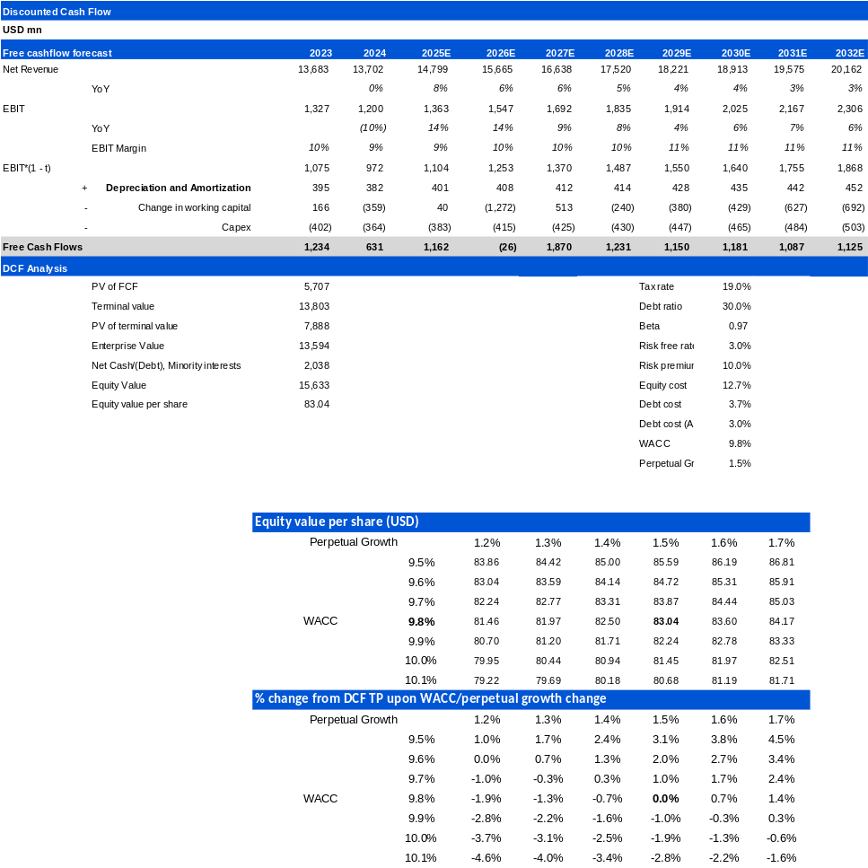
资料来源: Wind, HFI

Figure：Financial Summary
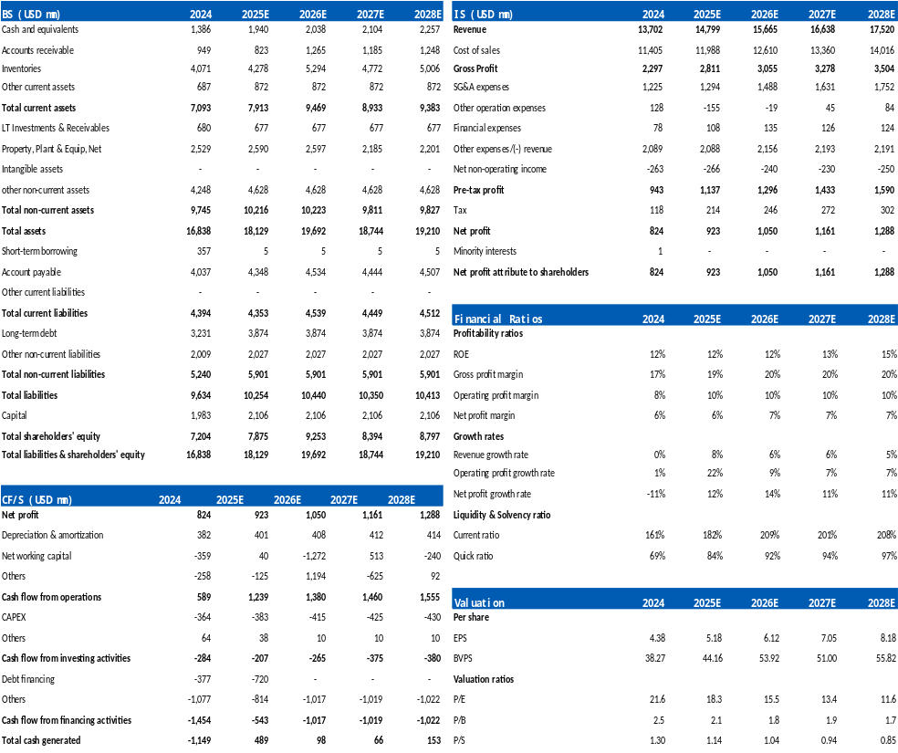
资料来源: Wind, HFI

7. Risk
Raw material price fluctuations; supply chain disruptions; intensified market competition; changes in customer demand and preferences; policy enforcement falling short of expectations
[Table_disclaimer]
附录APPENDIX
重要信息披露
本研究报告由华福国际（香港）金融控股有限公司（下称华福国际）分销，在其许可的司法管辖区内从事证券活动。
IMPORTANT DISCLOSURES
This research report is distributed by HuaFu International (HK) Financial Holdings Limited (referred as HuaFu International below), which is authorized to engage in securities activities in its respective jurisdiction.
分析师认证Analyst Certification:
我， xxxx，在此保证（i）本研究报告中的意见准确反映了我们对本研究中提及的任何或所有目标公司或上市公司的个人观点，并且（ii）我的报酬中没有任何部分与本研究报告中表达的具体建议或观点直接或间接相关；及就此报告中所讨论目标公司的证券，我们（包括我们的家属）在其中均不持有任何财务利益。I, xxxx, certify that (i) the views expressed in this research report accurately reflect my personal views about any or all of the subject companies or issuers referred to in this research and (ii) no part of my compensation was, is or will be directly or indirectly related to the specific recommendations or views expressed in this research report; and that I (including members of my household) have no financial interest in the security or securities of the subject companies discussed.
利益冲突披露Conflict of Interest Disclosures
华福国际及其某些关联公司可从事投资银行业务和/或对本研究中的特定股票或公司进行做市或持有自营头寸。就本研究报告而言，如需了解其中提到的某一公司信息，请发邮件至lcd@hfisec.com.hk）
HuaFu International and some of its affiliates may engage in investment banking and / or serve as a market maker or hold proprietary trading positions of certain stocks or companies in this research report. As far as this research report is concerned, please send an email to lcd@hfisec.com.hk if the information about any company mentioned in this report is needed).
评级定义（从2020年7月1日开始执行）：
华福国际采用相对评级系统来为投资者推荐我们覆盖的公司：优于大市、中性或弱于大市。投资者应仔细阅读华福国际的评级定义。并且华福国际发布分析师观点的完整信息，投资者应仔细阅读全文而非仅看评级。在任何情况下，分析师的评级和研究都不能作为投资建议。投资者的买卖股票的决策应基于各自情况（比如投资者的现有持仓）以及其他因素。
分析师股票评级
优于大市，未来12-18个月内预期相对基准指数涨幅在10%以上，基准定义如下
中性，未来12-18个月内预期相对基准指数变化不大，基准定义如下
弱于大市，未来12-18个月内预期相对基准指数跌幅在10%以上，基准定义如下
各地股票基准指数：日本 – TOPIX, 韩国 – KOSPI, 台湾 – TAIEX, 印度 – Nifty100, 美国 – SP500; 其他所有中国概念股 – MSCI China.
Ratings Definitions (from 1 Jul 2020):
HuaFu International uses a relative rating system using Outperform, Neutral, or Underperform for recommending the stocks we cover to investors. Investors should carefully read the definitions of all ratings used in HuaFu International Research. In addition, since HuaFu International Research contains more complete information concerning the analyst's views, investors should carefully read HuaFu International Research, in its entirety, and not infer the contents from the rating alone. In any case, ratings (or research) should not be used or relied upon as investment advice. An investor's decision to buy or sell a stock should depend on individual circumstances (such as the investor's existing holdings) and other considerations.
Analyst Stock Ratings
Outperform: The stock’s total return over the next 12-18 months is expected to exceed the return of its relevant broad market benchmark by over 10%, as indicated below.
Neutral: The stock’s total return over the next 12-18 months is expected to be in line with the return of its relevant broad market benchmark, as indicated below. Underperform: The stock’s total return over the next 12-18 months is expected to be below the return of its relevant broad market benchmark by over 10%, as indicated below.
Benchmarks for each stock’s listed region are as follows: Japan – TOPIX, Korea – KOSPI, Taiwan – TAIEX, India – Nifty100, US – SP500; for all other China-concept stocks – MSCI China.

华福国际非评级研究：华福国际发布计量、筛选或短篇报告，并在报告中根据估值和其他指标对股票进行排名，或者基于可能的估值倍数提出建议价格。这种排名或建议价格并非为了进行股票评级、提出目标价格或进行基本面估值，而仅供参考使用。
HuaFu International Non-Rated Research: HuaFu International publishes quantitative, screening or short reports which may rank stocks according to valuation and other metrics or may suggest prices based on possible valuation multiples. Such rankings or suggested prices do not purport to be stock ratings or target prices or fundamental values and are for information only.
华福国际A股覆盖：华福国际可能会就中国A股进行覆盖及评级。华福证券，华福国际于福州的母公司，也会于中国发布中国A股的研究报告。但是，华福国际使用与华福证券不同的评级系统，且可能有完全独立的不同研究覆盖团队，所以华福国际与华福证券的中国A股评级、目标价乃至分析逻辑可能有所不同。
HuaFu International Coverage of A-Shares: HuaFu International may cover and rate A-Shares . HuaFu Securities, the ultimate parent company of HuaFu International based in FuZhou, covers and publishes research on these same A-Shares for distribution in mainland China. However, the rating system employed by HuaFu International differs from that used by HuaFu Securites and even the teams covering the same A-share stocks might be totally independently different, as a result there may be a difference in their coverage ratings, target prices and research logics for the same A-share stocks.
重要免责声明：
本报告由华福国际发行，该公司是根据香港证券及期货条例（第571章）持有第4类受规管活动（就证券提供意见）的持牌法团。
本文件所载信息和观点已被编译或源自可靠来源，但华福国际或任何其他属于华福国际的成员对其准确性、完整性和正确性不做任何明示或暗示的声明或保证。本文件中所有观点均截至本报告日期，如有更改，恕不另行通知。本文件仅供参考使用。文件中提及的任何公司或其股票的说明并非意图展示完整的内容，本文件并非/不应被解释为对证券买卖的明示或暗示地出价或征价。在某些司法管辖区，本文件中提及的证券可能无法进行买卖。如果投资产品以投资者本国货币以外的币种进行计价，则汇率变化可能会对投资产生不利影响。过去的表现并不一定代表将来的结果。某些特定交易，包括设计金融衍生工具的，有产生重大风险的可能性，因此并不适合所有的投资者。您还应认识到本文件中的建议并非为您量身定制。分析师并未考虑到您自身的财务情况，如您的财务状况和风险偏好。因此您必须自行分析并在适用的情况下咨询自己的法律、税收、会计、金融和其他方面的专业顾问，以期在投资之前评估该项建议是否适合于您。若由于使用本文件所载的材料而产生任何直接或间接的损失，华福国际及其董事、雇员或代理人对此均不承担任何责任。
除对本文内容承担责任的分析师除外，华福国际及我们的关联公司、高级管理人员、董事和雇员，均可不时作为主事人就本文件所述的任何证券或衍生品持有长仓或短仓以及进行买卖。华福国际的销售员、交易员和其他专业人士均可向华福国际的相关客户和公司提供与本文件所述意见相反的口头或书面市场评论意见或交易策略。华福国际可做出与本文件所述建议或意见不一致的投资决策。但华福国际没有义务来确保本文件的收件人了解到该等交易决定、思路或建议。
请访问华福国际网站 www.hfisec.com.hk ，查阅更多有关华福国际为预防和避免利益冲突设立的组织和行政安排的内容信息。
IMPORTANT DISCLAIMER
The research report is issued by HuaFu International, a licensed corporation to carry on Type 4 regulated activity (advising on securities) for the purpose of the Securities and Futures Ordinance (Cap. 571) of Hong Kong.
The information and opinions contained in this research report have been compiled or arrived at from sources believed to be reliable and in good faith but no representation or warranty, express or implied, is made by HuaFu International or any other related members from which this research report may be received, as to their accuracy, completeness or correctness. All opinions expressed herein are as of the date of this research report and are subject to change without notice. This research report is for information purpose only. Descriptions of any companies or their securities mentioned herein are not intended to be complete and this research report is not, and should not be construed expressly or impliedly as, an offer to buy or sell securities. The securities referred to in this research report may not be eligible for purchase or sale in some jurisdictions. If an investment product is denominated in a currency other than an investor's home currency, a change in exchange rates may adversely affect the investment. Past performance is not necessarily indicative of future results. Certain transactions, including those involving derivatives, give rise to substantial risk and are not suitable for all investors. You should also bear in mind that recommendations in this research report are not tailor-made for you. The analyst has not taken into account your unique financial circumstances, such as your financial situation and risk appetite. You must, therefore, analyze and should, where applicable, consult your own legal, tax, accounting, financial and other professional advisers to evaluate whether the recommendations suits you before investment. Neither HuaFu International nor any of its directors, employees or agents accepts any liability whatsoever for any direct or consequential loss arising from any use of the materials contained in this research report.
HuaFu International and its affiliates, officers, directors, and employees, excluding the analysts responsible for the content of this document, will from time to time have long or short positions in, act as principal in, and buy or sell, the securities or derivatives, if any, referred to in this research report. Sales, traders, and other professionals of HuaFu International may provide oral or written market commentary or trading strategies to the relevant clients and the companies within HuaFu International that reflect opinions that are contrary to the opinions expressed in this research report. HuaFu Internatioal may make investment decisions that are inconsistent with the recommendations or views expressed in this research report. HuaFu International is under no obligation to ensure that such other trading decisions, ideas or recommendations are brought to the attention of any recipient of this research report.
Please refer to XXX’s website www.hfisec.com.hk for further information on HuaFu International’s organizational and administrative arrangements set up for the prevention and avoidance of conflicts of interest with respect to Research.

分发和地区通知：
除非下文另有规定，否则任何希望讨论本报告或者就本项研究中讨论的任何证券进行任何交易的收件人均应联系其所在国家或地区的华福国际销售人员。
香港投资者的通知事项：华福国际负责分发该研究报告，华福国际是在香港有权实施第1类受规管活动（从事证券交易）的持牌公司。该研究报告并不构成《证券及期货条例》（香港法例第571章）（以下简称“SFO”）所界定的要约邀请，证券要约或公众要约。本研究报告仅提供给SFO所界定的“专业投资者”。本研究报告未经过证券及期货事务监察委员会的审查。您不应仅根据本研究报告中所载的信息做出投资决定。本研究报告的收件人就研究报告中产生或与之相关的任何事宜请联系华福国际销售人员。
DISTRIBUTION AND REGIONAL NOTICES
Except as otherwise indicated below, any Recipient wishing to discuss this research report or effect any transaction in any security discussed in HuaFu International’s research should contact the HuaFu International salesperson in their own country or region.
Notice to Hong Kong investors: The research report is distributed by HuaFu International, which is a licensed corporation to carry on Type 1 regulated activity (dealing in securities) in Hong Kong. This research report does not constitute a solicitation or an offer of securities or an invitation to the public within the meaning of the SFO. This research report is only to be circulated to "Professional Investors" as defined in the SFO. This research report has not been reviewed by the Securities and Futures Commission. You should not make investment decisions solely on the basis of the information contained in this research report. Recipients of this research report are to contact HuaFu International salespersons in respect of any matters arising from, or in connection with, the research report.

中华人民共和国的通知事项：在中华人民共和国（下称“中国”，就本报告目的而言，不包括香港特别行政区、澳门特别行政区和台湾）只有根据适用的中国法律法规而收到该材料的人员方可使用该材料。并且根据相关法律法规，该材料中的信息并不构成“在中国从事生产、经营活动”。本文件在中国并不构成相关证券的公共发售或认购。无论根据法律规定或其他任何规定，在取得中国政府所有的批准或许可之前，任何法人或自然人均不得直接或间接地购买本材料中的任何证券或任何实益权益。接收本文件的人员须遵守上述限制性规定。
本项研究仅供收件人使用，未经华福国际的书面同意不得予以复制和再次分发。
版权所有：华福国际2025年。保留所有权利。
People’s Republic of China (PRC): In the PRC, the research report is directed for the sole use of those who receive the research report in accordance with the applicable PRC laws and regulations. Further, the information on the research report does not constitute "production and business activities in the PRC" under relevant PRC laws. This research report does not constitute a public offer of the security, whether by sale or subscription, in the PRC. Further, no legal or natural persons of the PRC may directly or indirectly purchase any of the security or any beneficial interest therein without obtaining all prior PRC government approvals or licenses that are required, whether statutorily or otherwise. Persons who come into possession of this research are required to observe these restrictions.
This research report is intended for the recipients only and may not be reproduced or redistributed without the written consent of an authorized signatory of HuaFu International.
Copyright: HuaFu International 2025. All rights reserved

Recommendation Chart
[Table_RecommendationChart]
Source: Company data Bloomberg, XXX estimates

